https://www.microsoft.com/en-us/translator/getstarted.aspx

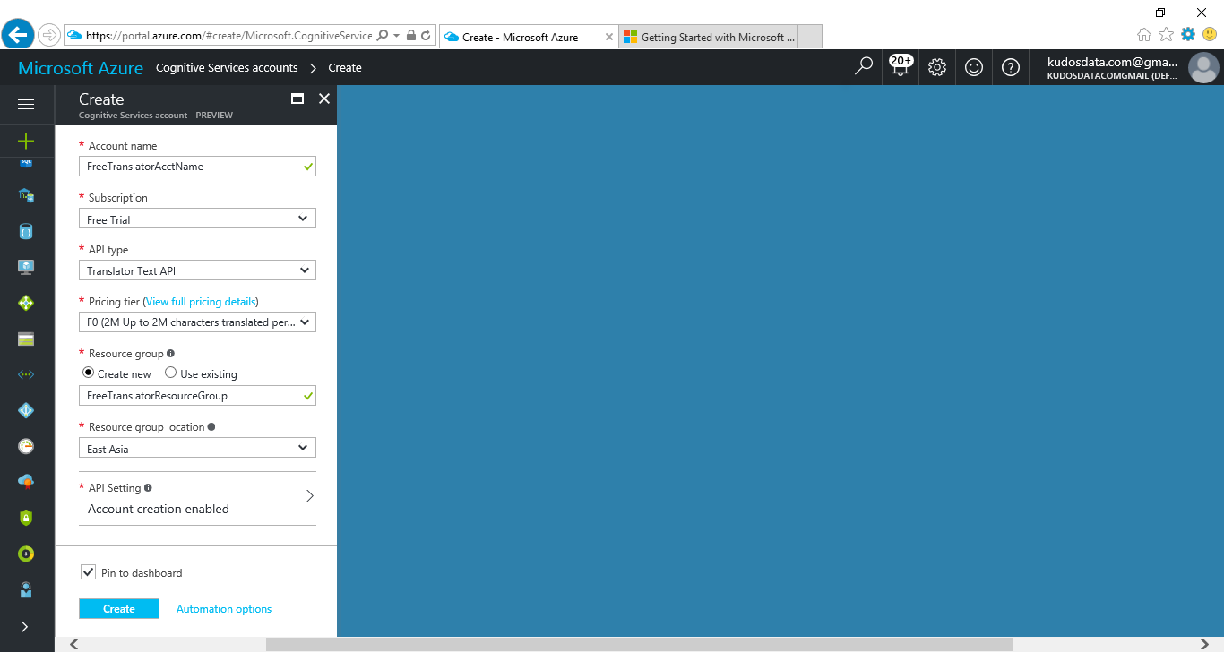

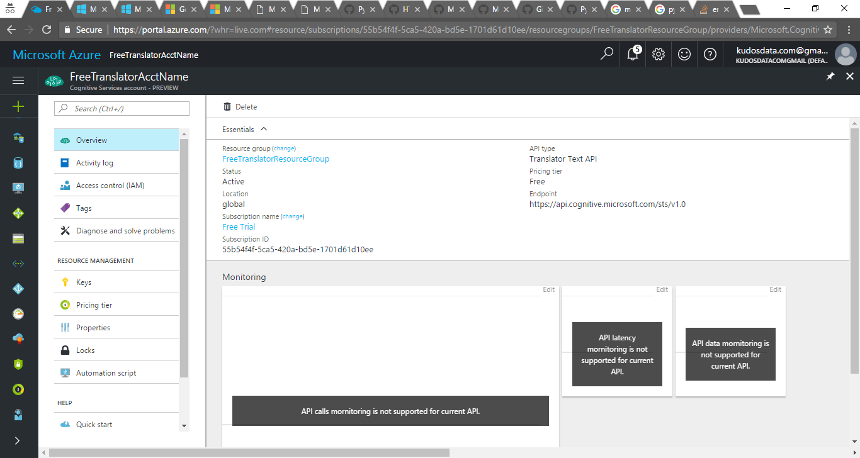

**Essentials**

* Resource group ([change](https://portal.azure.com/))

[FreeTranslatorResourceGroup](https://portal.azure.com/)

* API type

Translator Text API

* Status

Active

* Pricing tier

Free

* Location

global

* Endpoint

https://api.cognitive.microsoft.com/sts/v1.0

* Subscription name ([change](https://portal.azure.com/))

[Free Trial](https://portal.azure.com/)

* Subscription ID

55b54f4f-5ca5-420a-bd5e-1701d61d10ee